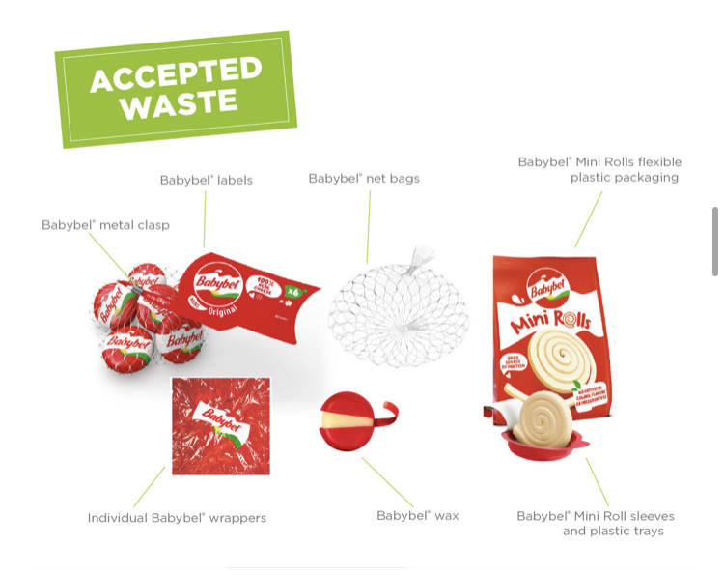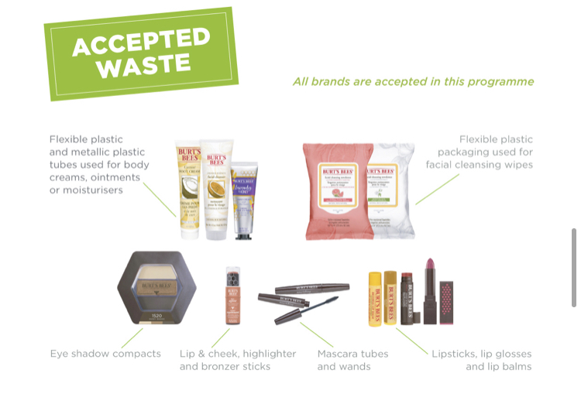

Untitled Event

7 August 2021

7–10 pm

The Location

123 High Street, Anytown, County, Postcode

www.example.com

7 August 2021

7–10 pm

The Location

123 High Street, Anytown, County, Postcode

www.example.com

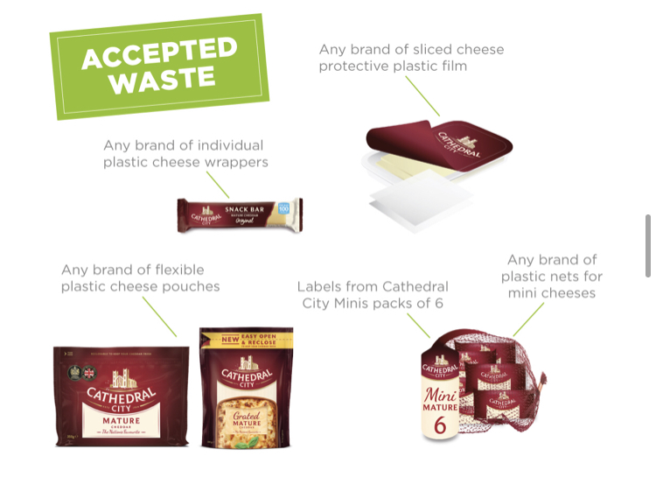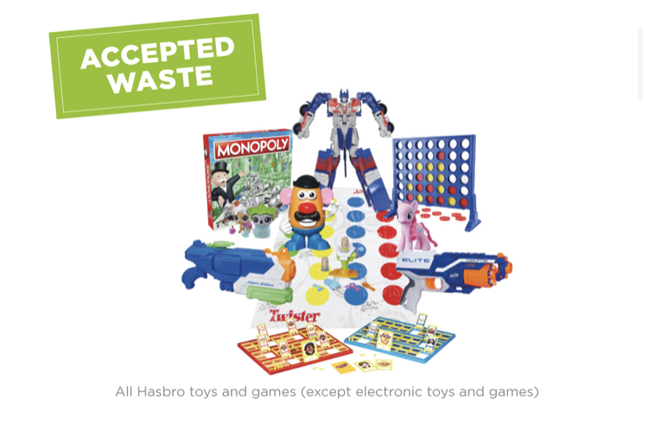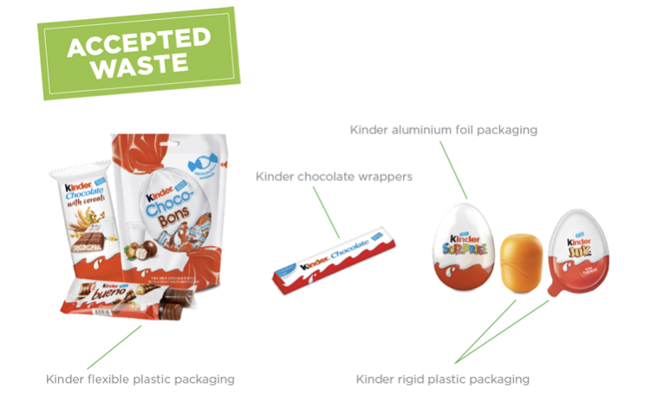

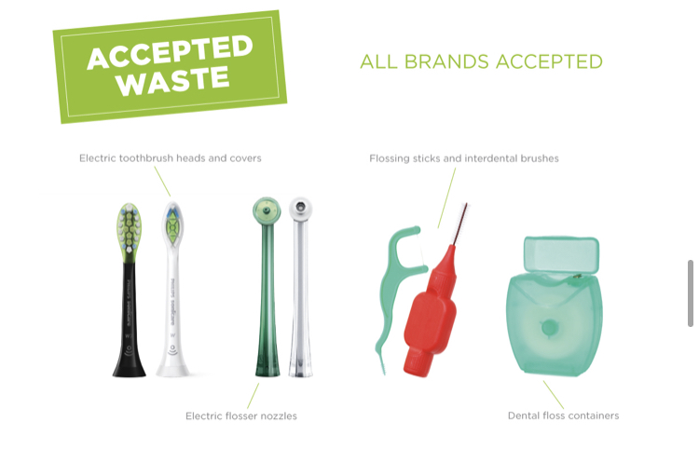

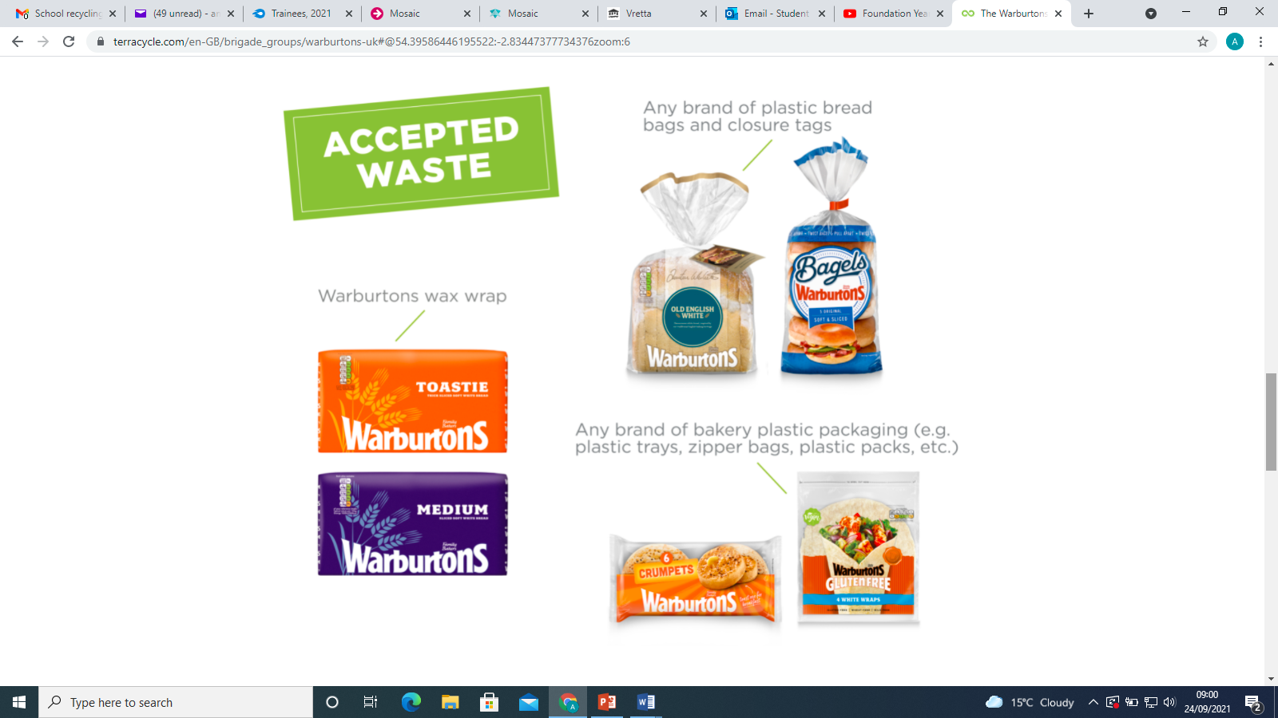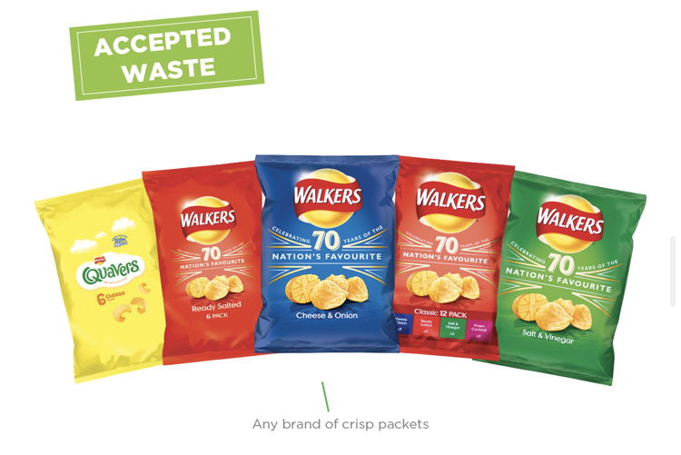

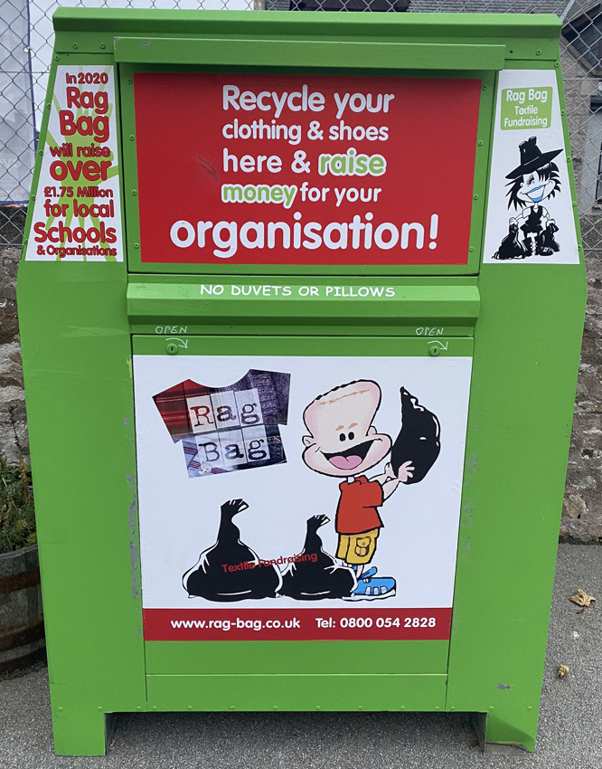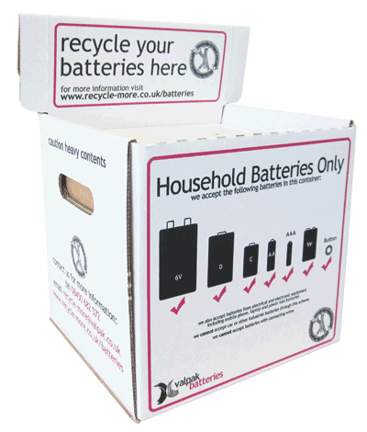

Ragbag Scheme

Accepted waste-

Battery recycling programme (Valpak)

Accepted waste-

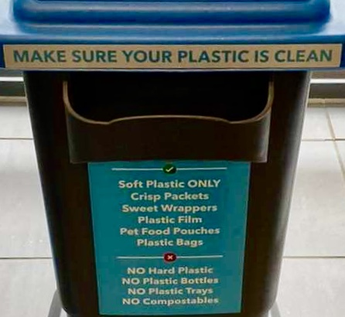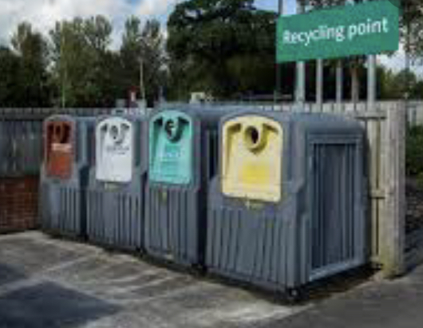

Co-op

ALL Co-op stores now have a plastic recycling bin in store.

Accepted Waste includes:

Morrisons, Tesco, Asda

ALL have waste recycling points located in their car parks.

Accepted waste includes:

recyclable plastic bags, films and wraps

Glass

Clothing

Please check your local store for details